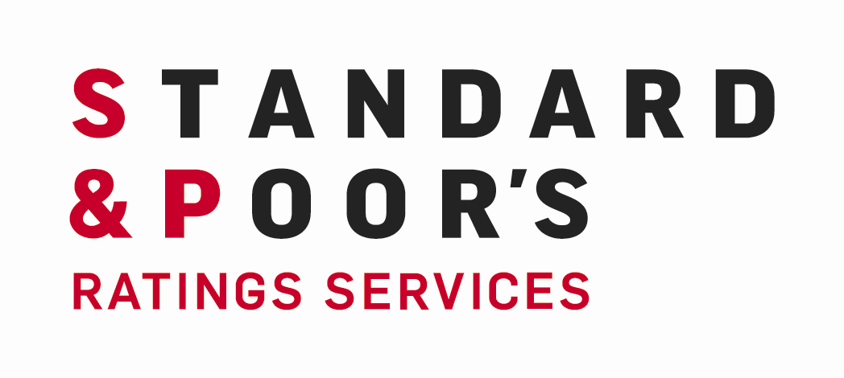

 | Martin Arrick  Managing Director  Corporate & Government Ratings  Martin Arrick is managing director in the Corporate & Government Ratings Group, and the senior analytical leader and group spokesman for the not-for-profit healthcare group. He is based in New York, and leads a team of healthcare analysts throughout the country. Martin is actively involved in all aspects of the healthcare practice including criteria development, and he serves as chair for many healthcare committees. Martin is also active in the long-term care practice, the ratings of several national and regional health systems.  Prior to joining Standard & Poor’s in 1990, Martin was a healthcare analyst in the New York State Comptroller’s Office. He has also held administrative positions in a hospital, a health maintenance organization, and the New York City Department of Health.  Martin has been ranked in Modern Health’s list of the 100 most influential people in the healthcare sector, and was named to Smith’s all-star research team. He has authored numerous publications and special reports on the healthcare sector, and was previously a member of the Healthcare Financial Management Association’s Principles and Practices Board.  Martin holds a B.A. from Case Western Reserve University and an M.B.A. and a Masters in Public Health from Columbia University.

