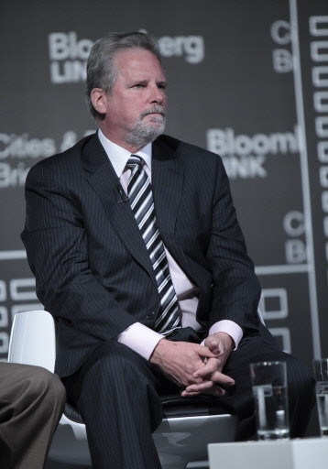
RICHARD P. LARKIN,
HERBERT J. SIMS & CO., INC.

Richard Larkin is a Senior Vice President and Director of Credit Analysis, joining Herbert J. Sims in February 2008. Dick worked at J.B. Hanauer from 2003-2008. Dick was a Managing Director in Fitch’s public finance group and served as the Co-chairman of its Public Finance Criteria Committee. Prior to joining Fitch in 1998, Dick was a Managing Director and Chief Municipal Rating Officer at Standard & Poor’s. Following a twenty-one year career at S&P, Dick served as a financial advisor to Fairmount Capital Advisors. Later, he helped found Reliance SRL, a rating agency that performed local credit ratings in Uruguay.
From 1988-1992, Dick was a charter member of the Anthony Commission on Public Finance. From 1995-1998, Dick served on the National Advisory Council on State & Local Budgeting (NACSLB). This industry task force, comprising representatives from the private sector and officials from all levels of local government, identified and fostered 60 of the best budgeting practices that have been implemented by our best-run state and local governments. Dick earned his BA in economics from Iona College and a Masters in economics from Fordham.

