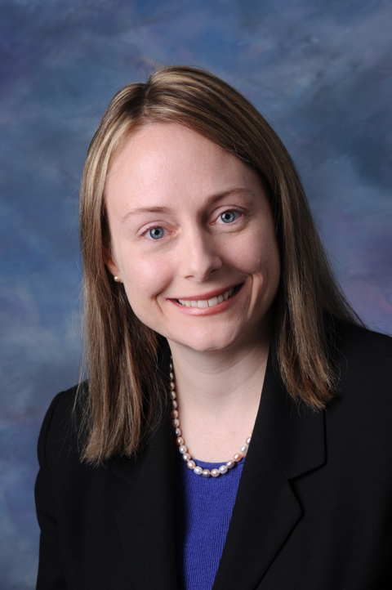
Rachel Cortez is a Vice President – Senior Credit Officer – Manager with the US Public Finance Group of Moody’s Investors Service. As Co-Manager of Moody’s Chicago office, Rachel oversees local government credits in several Midwest states, including Illinois. She has extensive experience covering tax-backed and revenue-secured credits issued by US local governments and not-for-profit health care organizations.

Prior to joining Moody’s in 2005, Rachel spent five years with American Management Systems (now CGI Group), where she implemented budget and financial management systems for states, cities, counties, and school districts. She was also a budget analyst with the State of Illinois Bureau of the Budget (now Office of Management and Budget) and spent several years working in development and fundraising for a Chicago not-for-profit organization.

Rachel is a former President of the Chicago Municipal Analysts Society (CMAS). She spent four years on the CMAS Board of Directors and the Board of Governors of the National Federation of Municipal Analysts (NFMA). Rachel received an MPA from the Maxwell School of Syracuse University and a BA in Government from Cornell University.

